19ECE384 OPEN LAB
REPORT

TITLE: WIRELESS MOBILE CHARGER

WIRELESS MOBILE CHARGER
Introduction:

Wireless charging technology enables wireless power transfer from a power source such as charger to a load such as a mobile device conveniently across an air gap by eliminating the bunch of wire. Wireless power transmission involves the exchange of power without the need for physical connections. These advancements established the basic principles that served as the foundation for modern electrical power transport. Public interest in wireless power has also increased with the application of Nikola Tesla ideas and inventions. As a result of this, the feasibility of technological implementation merits examination.

The inventions developed during this time were more advanced than anything that had been seen before, solving challenging problems and developing the basic theories that yielded modern technology. These inventors’ patents, papers, and experiments effectively describe the practicality and utility of wireless power propagation

Methodology:
- Power is transferred from transmitter to the receiver wirelessly based on the principle of “Inductive Coupling"
- This is because, as the current is flowing in the conductor, a magnetic flux is induced in it.
- This induced magnetic flux links with another conductor and this flux induces voltage in the second conductor
- Thus two conductors are said to be inductively coupled.

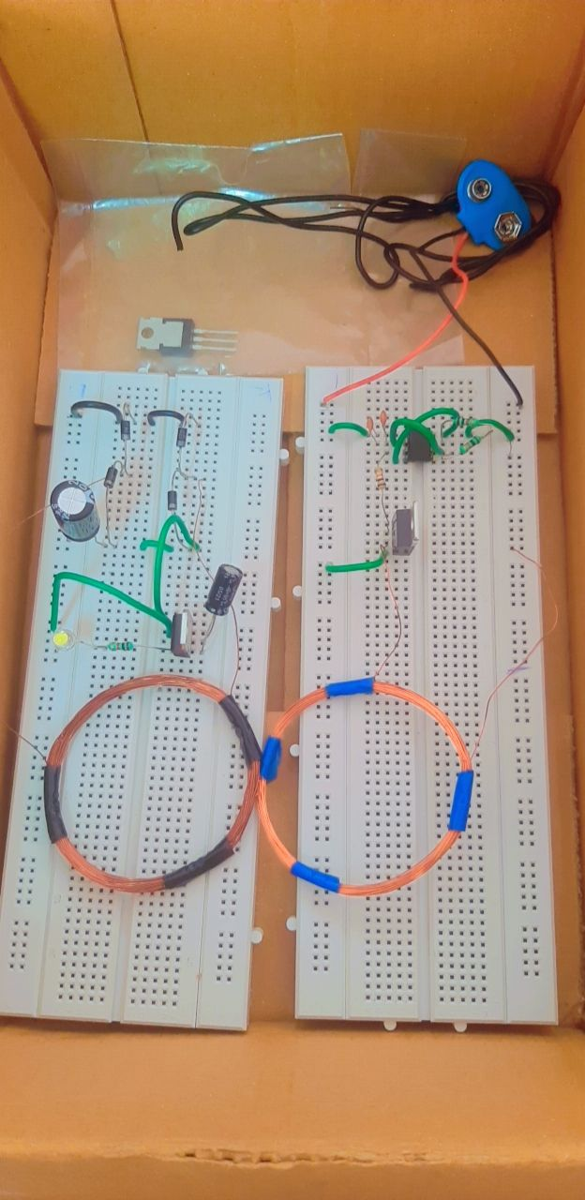

Inside view of Mobile for charge

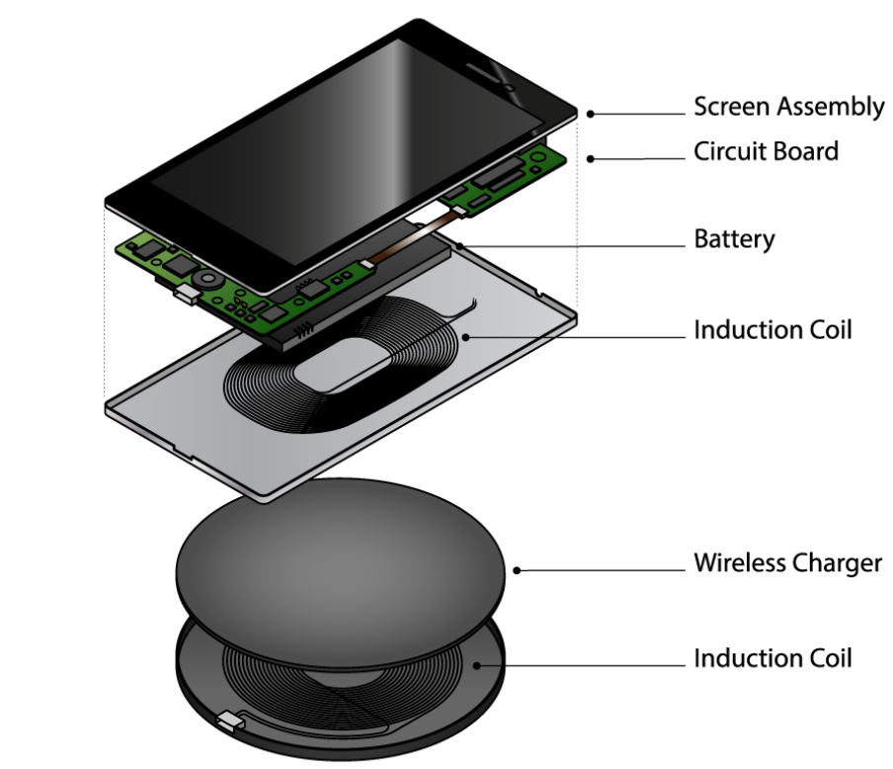
- Inside your smartphone is a receiver induction coil made of copper
- The wireless charger contains a copper transmitter coil
- When you place your phone on the charger, the transmitter coil generates an electromagnetic field that the receiver converts to electricity for the phone battery. This process is known as electromagnetic induction

Circuit design
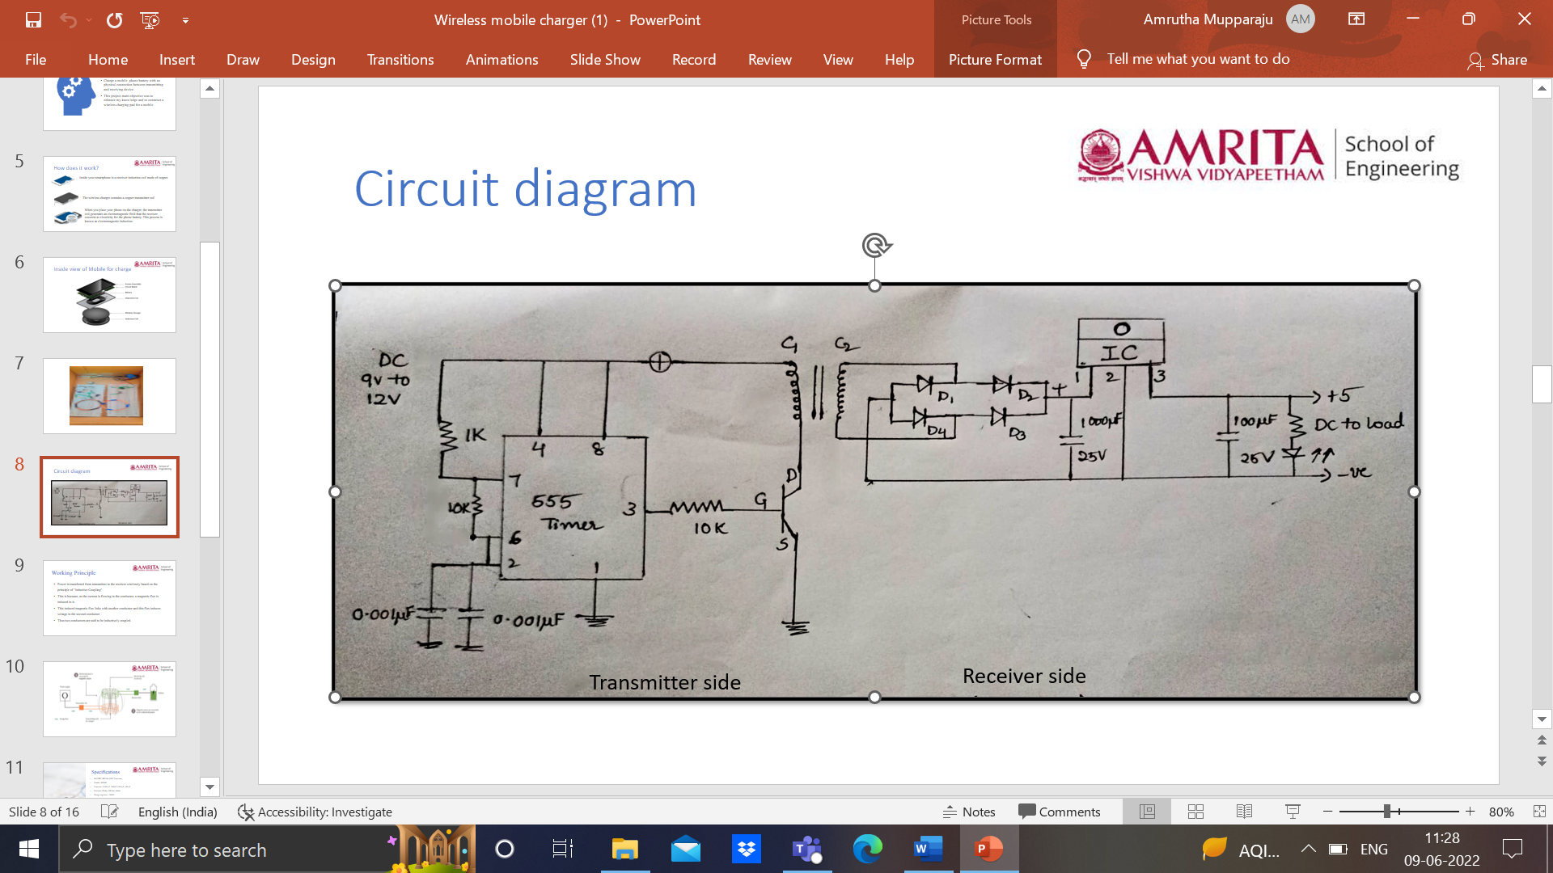

Results:
Without power supply
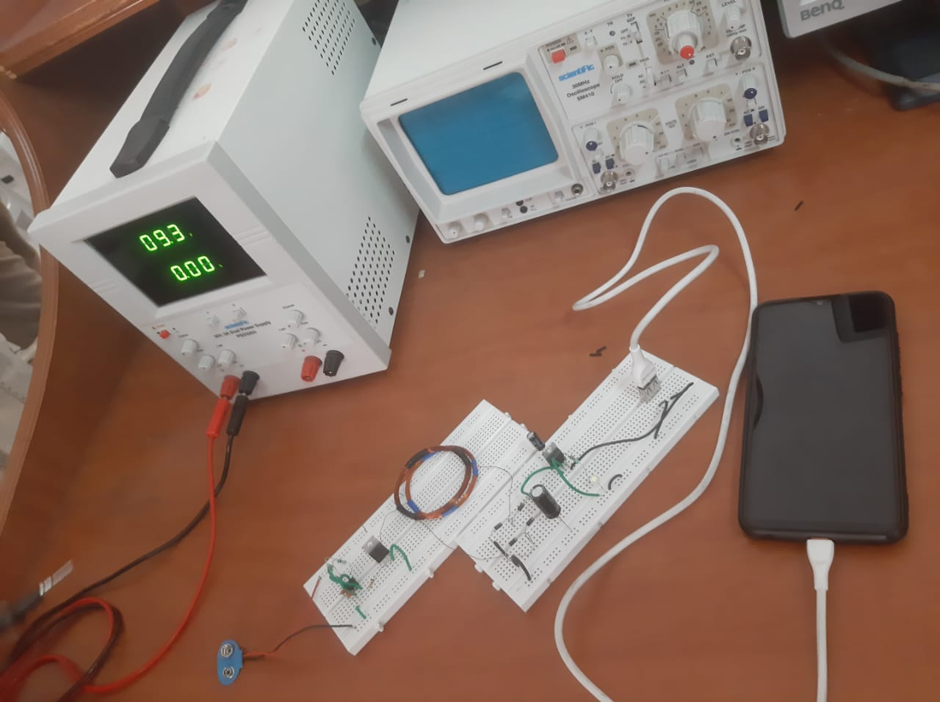

with power supply:
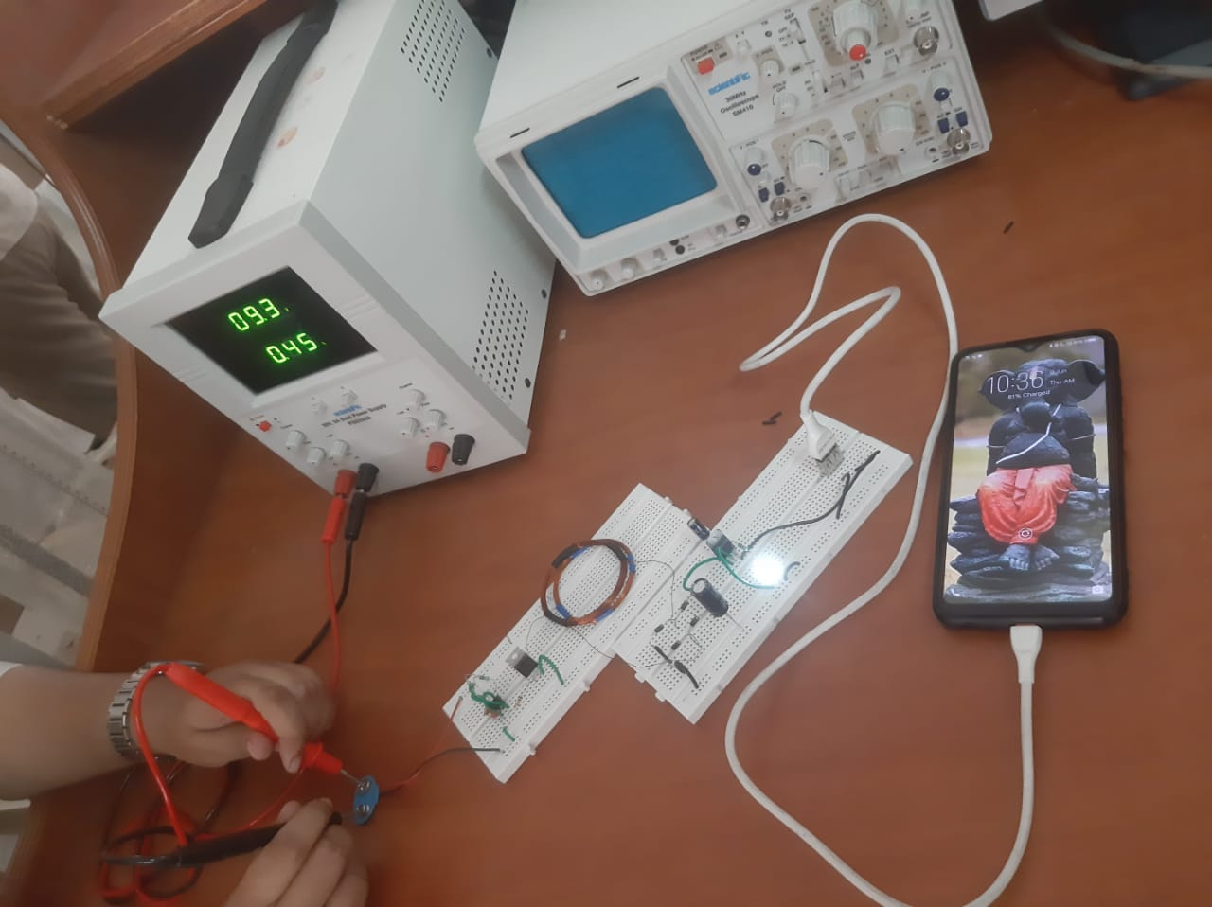

- Circuit design is done
- Bread board connections are done
- Mobile is charging successfully for 9V Supply

Specifications QTY & Ratings
MOSFET | IRFZ44N (NPN)
Diodes | IN4007
Resistors | 1K - 2,10K - 2
Capacitor | 0.001UF - 2, 1000UF,100UF
Oscillator | 555 Timer chip
Battery | DC voltage source(9V)
Copper Coils | 2
Voltage regulator | L7805CV
LED | 1
Bread board | 2
Mobile | 1
USB port | 1
Connecting wires | 10

References :
https://arxiv.org/pdf/1509.00940.pdf
https://www.researchgate.net/publication/267695945_Wireless_Charger_Networking_for_Mobile_Devices_Fundamentals_Standards_and_Applications
https://ieeexplore.ieee.org/document/8397783
https://www.sciencedirect.com/science/article/pii/S2352146521004610
https://www.instructables.com/DIY-Wireless-Charger/
wireless charger networking

